**Exercise 1: Setting Up Junit**

**Scenario: You need to set up JUnit in your Java project to start writing unit tests.**

**CODE :**

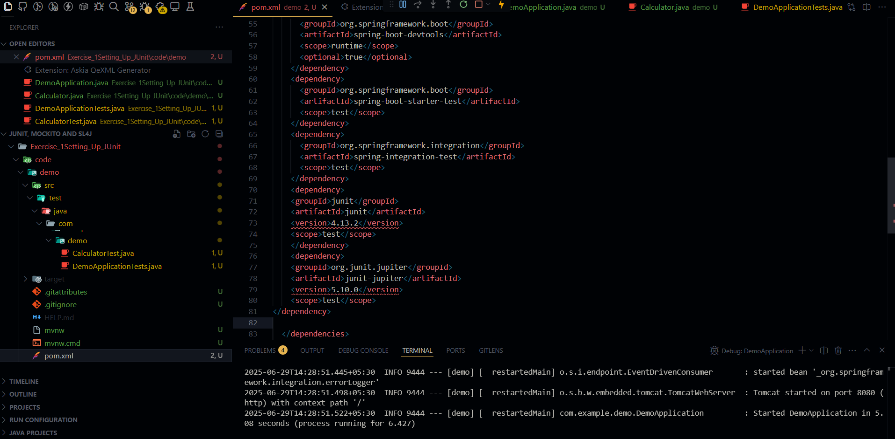

**OUTPUT:**

